**Web Application Development**

**BCA-DS-304**

Manav Rachna International Institute of Research and Studies School of Computer Applications

Department of Computer Applications

|  |  |
| --- | --- |
| **Submitted By** | |
| **Student Name** | **Vivaan Shahi** |
| **Roll No** | **23/SCA/BCA(CS)/041** |
| **Programme** | **Bachelor of Computer Applications** |
| **Semester** | **3rd Semester** |
| **Section/Group** | **3D** |
| **Department** | **School of Computer Applications** |
| **Batch** | **2023-26** |
|  | |
| **Submitted To** | |
| **Faculty Name** | **Dr. Ritu Sachdeva** |

**SCHOOL OF COMPUTER APPLICATIONS**

|  |  |  |  |  |
| --- | --- | --- | --- | --- |
| **S. No.** | **Date** | **Aim of the Program** | **Signature/Date** | **Grade** |
| **1** | **16/07/2074** | Create a simple HTML page using basic tags. |  |  |
| **2** | **18/07/2074** | Create a web page that displays your name to the screen. |  |  |
| **3** | **20/07/2074** | Create a web page and show the output from 1 to 10 in separate lines. |  |  |
| **4** | **22/07/2074** | Create a web page and show the output from 1 to 10 in separate lines, each number being in a different color. |  |  |
| **5** | **10/08/2074** | How to make a picture as background on my web pages? |  |  |
| **6** | **12/08/2074** | Create a web page to print a paragraph with 4-5 sentences, each sentence shall have a different font. |  |  |
| **7** | **14/08/2074** | Write HTML code to print a paragraph that is a description of a book; it shall include the title of the book, author name, and the name and title should be underlined, adjectives should be bold, and italics used. |  |  |
| **8** | **16/08/2074** | Write HTML code to print your name using Heading tag, every letter shall be of different heading size. |  |  |
| **9** | **18/08/2074** | Write HTML code to print the sequence of numbers 1-20. Each number shall be in a different line with number 2 next to its subscript, an equal sign, and the result.. |  |  |
| **10** | **20/08/2024** | Write HTML code to display an image with border of size width 200, height 200 pixels, leaving Hspace and Vspace of your choice with image hanging on the right side on the screen. |  |  |
| **11** | **22/08/2024** | Write HTML code to create a web page with heading. The heading shall be displayed at the top-center of the page and the image shall be at the center, just below the heading. |  |  |
| **12** | **24/08/2024** | Write HTML code using Multimedia tags. |  |  |

Program No: 1

Student Name: Vivaan Shahi

UID:23/SCA/BCA(CS)/041

Date of Performance: 16.07.2074

AIM - Create a simple HTML page using basic tags.

EXECUTION-

<!DOCTYPE html>

<html>

<head>

<title>Simple HTML Page</title>

</head>

<body>

<h1>Welcome to My Simple HTML Page</h1>

<p>This is a basic HTML page using simple tags.</p>

</body>

</html>

**Result/Output/Writing Summary:**

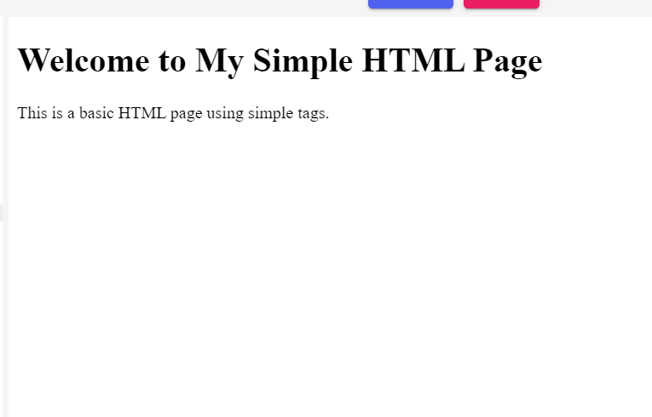

Program No: 2

Student Name: Vivaan Shahi

UID:23/SCA/BCA(CS)/041

Date of Performance: 18.07.2074

**AIM -** 2. Create a web page that displays your name to the screen.

EXECUTION-

**<!DOCTYPE html>**

**<html>**

**<head>**

**<title>Display Name</title>**

**</head>**

**<body>**

**<h1> harshit </h1>**

**</body>**

**</html>**

**Result/Output/Writing Summary:**



Program No: 3

Student Name: Vivaan Shahi

UID:23/SCA/BCA(CS)/041

Date of Performance:20.07.24

**AIM - Create a web page and show the output from 1 to 10 in separate lines.**

EXECUTION-

**<!DOCTYPE html>**

**<html>**

**<head>**

**<title>Numbers 1 to 10</title>**

**</head>**

**<body>**

**<p>1</p>**

**<p>2</p>**

**<p>3</p>**

**<p>4</p>**

**<p>5</p>**

**<p>6</p>**

**<p>7</p>**

**<p>8</p>**

**<p>9</p>**

**<p>10</p>**

**</body>**

**</html>**

**Result/Output/Writing Summary:**



Program No: 4

Student Name: Vivaan Shahi

UID:23/SCA/BCA(CS)/041

Date of Performance:22.07.24

**AIM - Create a web page and show the output from 1 to 10 in separate lines, each number being in a different color.**

**<!DOCTYPE html>**

**<html>**

**<head>**

**<title>Colored Numbers</title>**

**</head>**

**<body>**

**<p style="color:red;">1</p>**

**<p style="color:green;">2</p>**

**<p style="color:blue;">3</p>**

**<p style="color:orange;">4</p>**

**<p style="color:purple;">5</p>**

**<p style="color:brown;">6</p>**

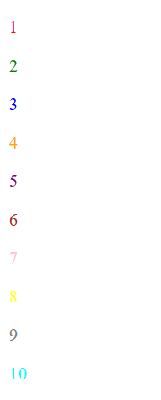 **<p style="color:pink;">7</p>**

**<p style="color:yellow;">8</p>**

**<p style="color:gray;">9</p>**

**<p style="color:cyan;">10</p>**

**</body>**

**</html>**

**Result/Output/Writing Summary:**

Program No: 5

Student Name: Vivaan Shahi

UID:23/SCA/BCA(CS)/041

Date of Performance:10.08.24

**AIM - How to make a picture as background on my web pages?**

**<!DOCTYPE html>**

**<html>**

**<head>**

**<title>Background Image</title>**

**<style>**

**body {**

**background-image: url('https://img.freepik.com/free-photo/colorful-bird-with-black-beak-blue-yellow-wing_1340-28826.jpg?t=st=1727600475~exp=1727601075~hmac=8bbe87b8a3db3f30418ce29a0859b3f67f343ca6547087b8cb08f3a218a95a53');**

**background-size: cover;**

**}**

**</style>**

**</head>**

**<body>**

**<h1 style=”color:white;”>Background Image Example</h1>**

**</body>**

**</html>**

**Result/Output/Writing Summary:**

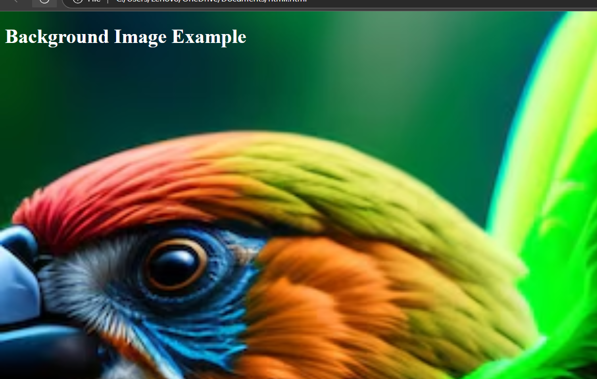

Program No: 6

Student Name: Vivaan Shahi

UID:23/SCA/BCA(CS)/041

Date of Performance:12.08.24

**AIM - Create a web page to print a paragraph with 4-5 sentences, each sentence shall have a different font.**

**<!DOCTYPE html>**

**<html>**

**<head>**

**<title>Different Fonts</title>**

**<style>**

**.font1 { font-family: Arial; }**

**.font2 { font-family: Times New Roman; }**

**.font3 { font-family: Courier New; }**

**.font4 { font-family: Verdana; }**

**</style>**

**</head>**

**<body>**

**<p class="font1">hi guys.</p>**

**<p class="font2">good morning.</p>**

**<p class="font3">its a wonderful monday.</p>**

**<p class="font4">and a beautiful starting of the week.</p>**

**</body>**

**</html>**

**Result/Output/Writing Summary:**

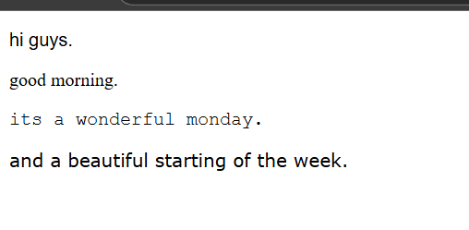

Program No: 7

Student Name: Vivaan Shahi

UID:23/SCA/BCA(CS)/041

Date of Performance:14.08.24

**AIM - Write HTML code to print a paragraph that is a description of a book; it shall include the title of the book, author name, and the name and title should be underlined, adjectives should be bold, and italics used.**

**<!DOCTYPE html>**

**<html>**

**<head>**

**<title>Book Description</title>**

**</head>**

**<body>**

**<p><u>The Great Adventure</u> is a <b>fantastic</b> and <i>exciting</i> book written by <u>John Doe</u>. The <b>amazing</b> journey takes place across <i>mysterious</i> lands.</p>**

**</body>**

**</html>**

**Result/Output/Writing Summary:**

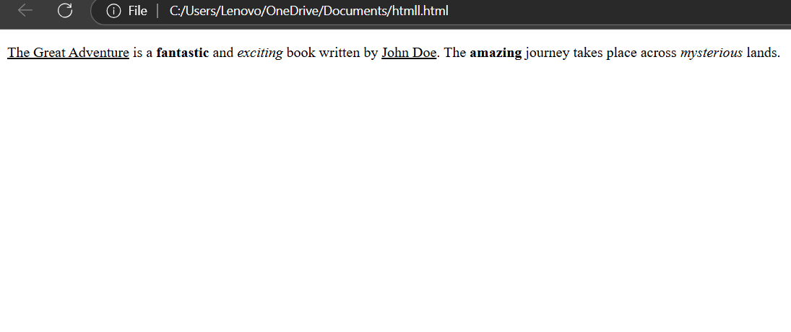

Program No: 8

Student Name: Vivaan Shahi

UID:23/SCA/BCA(CS)/041

Date of Performance:16.08.24

**AIM - Write HTML code to print your name using Heading tag, every letter shall be of different heading size.**

**<!DOCTYPE html>**

**<html>**

**<head>**

**<title>Name with Different Headings</title>**

**</head>**

**<body>**

**<h1>A</h1>**

**<h2>B</h2>**

**<h3>C</h3>**

**<h4>D</h4>**

**<h5>E</h5>**

**<h6>F</h6>**

**</body>**

**</html>**

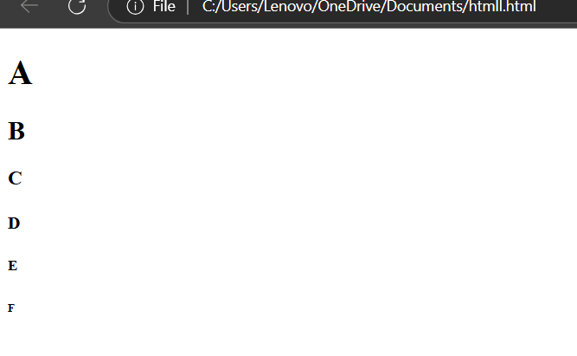**Result/Output/Writing Summary:**

Program No: 9

Student Name: Vivaan Shahi

UID:23/SCA/BCA(CS)/041

Date of Performance:18.08.24

**AIM - Write HTML code to print the sequence of numbers 1-20. Each number shall be in a different line with number 2 next to its subscript, an equal sign, and the result.**

**<!DOCTYPE html>**

**<html>**

**<head>**

**<title>Sequence with Subscript</title>**

**</head>**

**<body>**

**<p>1<sub>2</sub> = 2</p>**

**<p>2<sub>2</sub> = 4</p>**

**<p>3<sub>2</sub> = 6</p>**

**<!-- Add up to 20 -->**

**</body>**

**</html>**

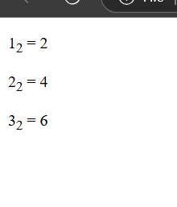**Result/Output/Writing Summary:**

Program No: 10

Student Name: Vivaan Shahi

UID:23/SCA/BCA(CS)/041

Date of Performance:20.08.24

**AIM - Write HTML code to display an image with border of size width 200, height 200 pixels, leaving Hspace and Vspace of your choice with image hanging on the right side on the screen.**

**<!DOCTYPE html>**

**<html>**

**<head>**

**<title>Image with Border</title>**

**</head>**

**<body>**

**<img src="image.jpg" width="200" height="200" hspace="20" vspace="20" align="right">**

**</body>**

**</html>**

**Result/Output/Writing Summary:**

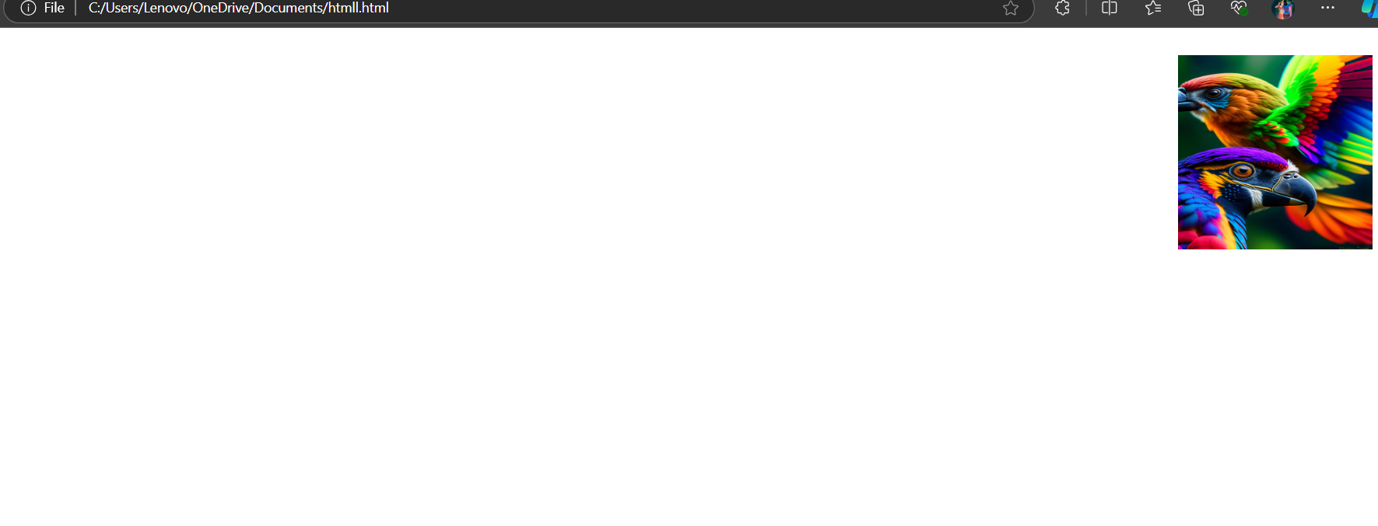

Program No: 11

Student Name: Vivaan Shahi

UID:23/SCA/BCA(CS)/041

Date of Performance:22.08.24

**AIM - Write HTML code to create a web page with heading. The heading shall be displayed at the top-center of the page and the image shall be at the center, just below the heading.**

**<!DOCTYPE html>**

**<html>**

**<head>**

**<title>Centered Heading and Image</title>**

**<style>**

**h1 {**

**text-align: center;**

**}**

**img {**

**display: block;**

**margin-left: auto;**

**margin-right: auto;**

**}**

**</style>**

**</head>**

**<body>**

**<h1>Centered Heading</h1>**

**<img src="image.jpg" alt="Centered Image">**

**</body>**

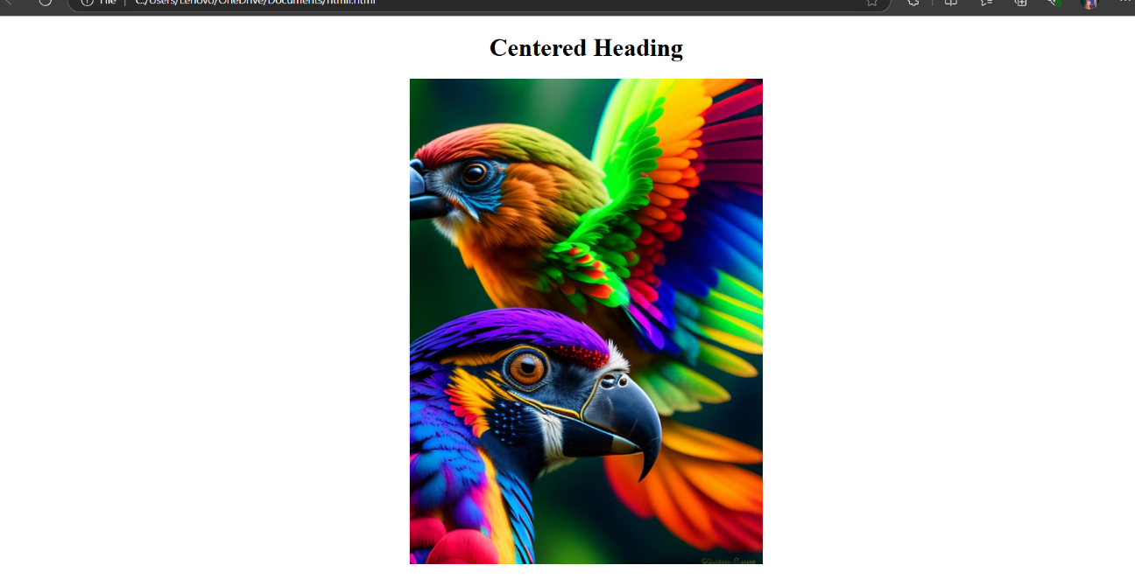**</html>**

**Result:**

Program No: 12

Student Name: Vivaan Shahi

UID:23/SCA/BCA(CS)/041

Date of Performance:24.08.24

**AIM - Write HTML code using Multimedia tags.**

**<!DOCTYPE html>**

**<html>**

**<head>**

**<title>Multimedia Example</title>**

**</head>**

**<body>**

**<h1>Audio and Video Example</h1>**

**<audio controls>**

**<source src="audio.mp3" type="audio/mpeg">**

**Your browser does not support the audio element.**

**</audio>**

**<video width="320" height="240" controls>**

**<source src="video.mp4" type="video/mp4">**

**Your browser does not support the video tag.**

**</video>**

**</body>**

**</html>**

**Result/Output/Writing Summary:**

